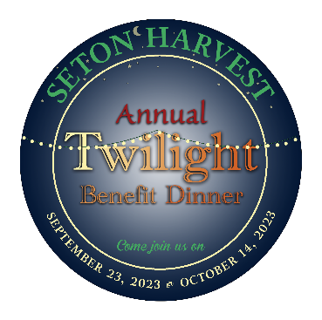
SPONSORSHIP PLEDGE FORM
2023 Dinner Dates
September 23 or October 14

COMPANY NAME: ______________________CONTACT PERSON: _______________________________

ADDRESS: _________________________CITY____________ STATE_________ Zip_________________

E-MAIL ADDRESS: __________________________________ TELEPHONE: _________________________

PLEASE RESERVE THE FOLLOWING TABLE OR FULL SPONSORSHIP FOR MY COMPANY:

GARDEN PATCH Table Sponsorship: Your logo will be prominently displayed on your sponsored table. Please select your preferred level:
- HERB Table Sponsor: $500 – Table sponsorship for both Twilight Dinners. Your logo added to our event program.
- TOMATO Table Sponsor: $250 – Table sponsorship of one Twilight Dinner. Your logo added to our event program.
  - September 23, 2023
  - October 14, 2023
- OKRA Table Sponsor: $150- Table sponsorship for one Twilight Dinner of your choice.
  - September 23, 2023
  - October 14, 2023
VEGETABLE GARDEN Sponsorship Package:
Historically, Seton Harvest has been able to produce one pound of produce for approximately $2.50. Therefore, we have based our full sponsor levels on the amount of produce you could impact with each level of donation. Additionally, you will receive tickets for dinners according to the sponsorship level chosen:
  - FLOWER DONOR $5,000 (2,000lbs of fresh produce) 6 tickets to dinner of choice
  - STEM DONOR $3,000 (1,200lbs of fresh produce) 4 tickets for the dinner of choice
  - SPROUT DONOR $1,500 (600lbs of fresh produce) 2 tickets for the dinner of choice
  - SEEDLING DONOR $1,000 (400lbs of fresh produce)

PAYMENT METHOD:
- Enclosed is my check payable to SETON HARVEST.
- Please invoice me at the address listed above. (Please remit payment no later than August 25, 2023)

For additional information, please contact:

Julie Dietz, Community Outreach Manager
julie.dietz@doc.org
(812)963-7692 office or (812)470-6597 cell

