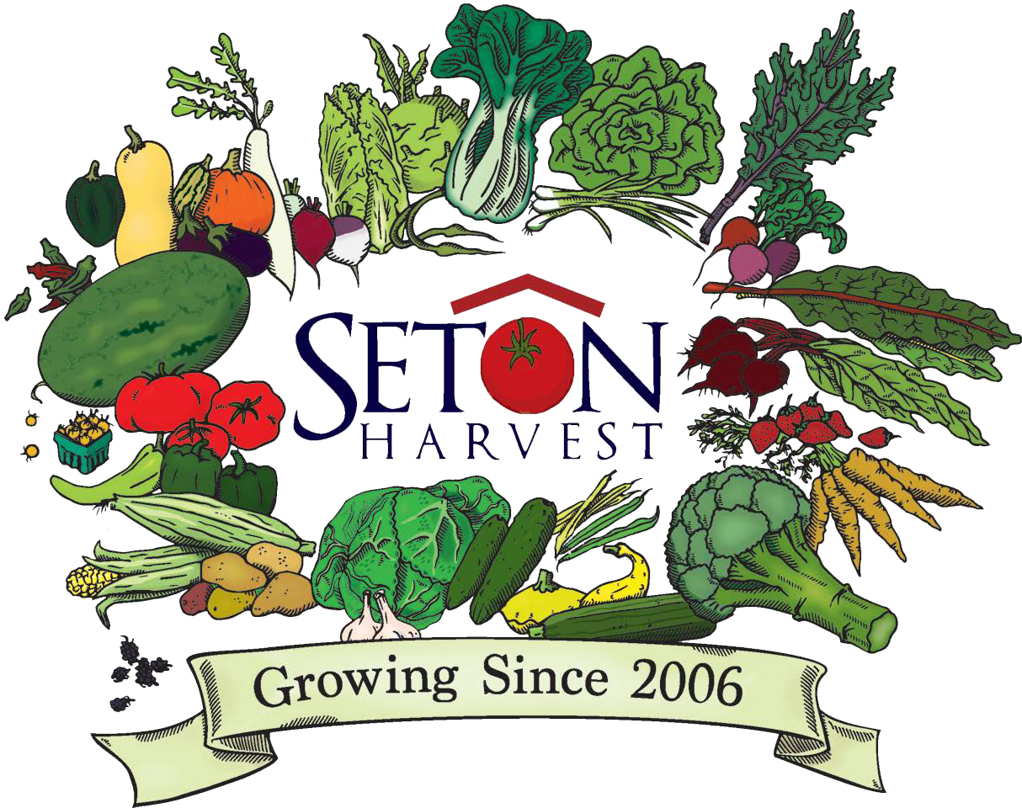
2024 Summer Farm Camp
Registration Form for Ages 6 to 10
Farm Camp Date: JULY 15-19 Fee $195 per child

Student Information
Child's Name |  | Home Street Address
Child's Date of Birth Gender |  | Home City | State | Zip
Child of Seton Harvest Shareholder YES NO |  | Child of Daughters of Charity employee YES NO
Parent/Guardian Name Cell Phone |  | Parent/Guardian Name | Cell Phone
Workplace Work Phone |  | Workplace | Work Phone
Preferred Email Address |  | Preferred Email Address
Other Information
Is there anything you would like Farm Camp staff to know about your child?
Media Release
I give my permission for my child’s photograph or video to be taken for use by Seton Harvest in program brochures, annual report, website, social media sites and other promotional materials and for release to local newspapers.

Signature of Parent or Guardian Date Declined
I, for myself and on behalf of my heirs, assigns, personal representatives and next of kin, HEREBY RELEASE, INDEMNIFY, AND HOLD HARMLESS Seton Harvest and the Daughters of Charity their officers, officials, agents and/ or employees, other participants, sponsoring agencies, sponsors, and, if applicable, owners and lessors of premises used for Farm Camp activities (“Releasees”), WITH RESPECT TO ANY AND ALL INJURY, DISABILITY, DEATH, or loss or damage to person or property, WHETHER ARISING FROM THE NEGLIGENCE OF THE RELEASEES OR OTHERWISE, to the fullest extent permitted by law.
LIABILITY WAIVER
The payment for my child is being made via: PayPal on website Seton Harvest mobile app
Check mailed with this application to Seton Harvest Attn: Farm Camp 9400 New Harmony Rd. Evansville, IN 47720
I am interested in applying for financial assistance.
I have read and agree to the above policies, and I am responsible for the registration fee.

Parent/Guardian Signature Date

Pick-up List
AUTHORIZED PICKUP LIST / EMERGENCY MEDICAL RELEASE

COMPLETE ONE FORM PER CHILD

Anyone picking up a camper must provide a photo I.D. and be listed below.
Parent/Guardian Name: Employer: Phone Number: Parent/Guardian Name: Employer: Phone Number:
List up to 3 other people (other than parent/guardian) who are authorized to pick up the camper and should be contacted in case of a medical emergency or emergency pick-up if parent/guardian cannot be reached.
- Name: Relationship: Phone Number:
- Name: Relationship: Phone Number:
- Name: Relationship: Phone Number:

Emergency Medical Release
In case of an emergency, I understand every effort will be made to contact me or the emergency contact persons listed above. In the event that we cannot be reached, I hereby give permission to the physician listed on the form, and the authorized individuals listed above, to hospitalize, secure proper treatment and to order anesthesia or surgery for my child.
Physician’s Name: Hospital Affiliation:

Address:
Medical Insurance Provider:

Allergies and Medications
Phone:
Policy and/or Group #:

Known Allergies:
Does your child need to take medication(s) during camp (circle one)? Yes No
If your child requires medication, please specify:
The Permission to Administer Medication form must be completed and given to the Camp Director on the first day of each camp session. Medications must be accompanied by the original physician’s prescription with clearly written directions. If your child has other special needs (language, learning disability, speech, hearing, food allergies, etc), please contact the Camp Director, Julie Dietz, at (812) 963-7692 prior to the first day of camp.
Policies
Sunscreen/Insect Repellent
I give permission for sunscreen or insect repellent to be administered and/or applied to my camper as deemed necessary by the camp staff.
Backpack Search
I agree that any camp participant’s belongings may be searched outside the participant’s presence for drugs, alcohol, weapons, or other forbidden objects.
Lost or Stolen Items
Campers are asked to leave any valuables and electronics at home. Seton Harvest and its employees are not responsible for lost or stolen items.
Behavior
Farm Camp at Seton Harvest is designed to provide children an opportunity to discover, play, and learn on a working farm. Many of the activities will be hands-on, including interaction with nature and animals. We ask that each camper act in a responsible and cooperative manner at all times. Those who are not able to participate in a respectful, safe manner will be asked to sit out.

Parent/Guardian Signature: Date:

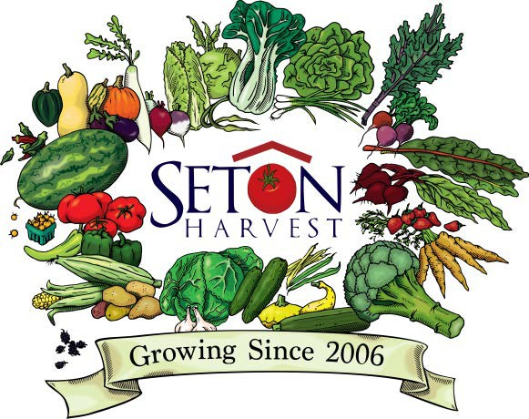
2024 Summer Farm Camp
Registration Form for Ages 6 to 10

Program Overview
Program Date | July 15-19, 2024
Program Days | Monday through Friday
Program Time | Drop-Off 8:15 - 8:30 am Pick-Up 3:00 - 3:15 pm
Free Snack Served | 10:30 am - 11:00 am
Lunch | 12:00 pm - 12:30 pm *Campers Bring Sack or Box Lunch
Fee | $195/child 10% discount for children of Seton Harvest Shareholders or DOC employees
Expectations | REGISTRATION & TUITION:  A registration form and tuition fee are due upon enrolling in the 2024 Farm Camp. Return the form and fee by mail to 9400 New Harmony Rd, Evansville, IN 47720 or fill out the application and make a payment on the @setonharvest mobile app. A registration form is not considered complete until all sections are filled out including emergency contact information, media release, consideration/allergy, and the policies and liability sections. Financial assistance may be available. Please contact julie.dietz@doc.org for information on how to apply.  Registration Deadline - June 30th  WITHDRAWALS & REFUNDS:  Withdrawing your child from Farm Camp must be made in writing at least 48 hours prior to the start date for a full refund. No refunds will be given after the program start date.  DROP-OFF / PICK-UP:  Drop-off at Seton Harvest will begin at 8:30 am. On the first day of Farm Camp, please park and walk your child to the check-in table in the pavilion. The remaining days of the week, Tuesday - Friday, please follow the car line signs that will make a loop around to the pavilion for drop-off and pick-up.  FARM CHORES & ATTIRE  Campers will be involved in helping with farm chores each morning during camp. These are not overly labor intensive and are designed for learning purposes. Campers will be highly encouraged to assist with planting, weeding, harvesting, and tending animals, however, they also have the option to choose not to participate by sitting and watching.  Along with farm chores, campers will also be hiking and exploring nature. It is important that they wear closed-toed shoes (NO flip-flops) and are dressed appropriately for the weather.  Reusable water bottles, exploration backpacks, and a souvenir t-shirt will be provided.
CONTACT: Julie Dietz, Camp Director at julie.dietz@doc.org or (812) 963-7692 SetonHarvest.org 9400 New Harmony Rd. Evansville, IN 47720

